Unit 5 - Continuous Probability Distributions

Continuous sample spaces and continuous random variables arise when we deal with quantities that are measured on a continuous scale.

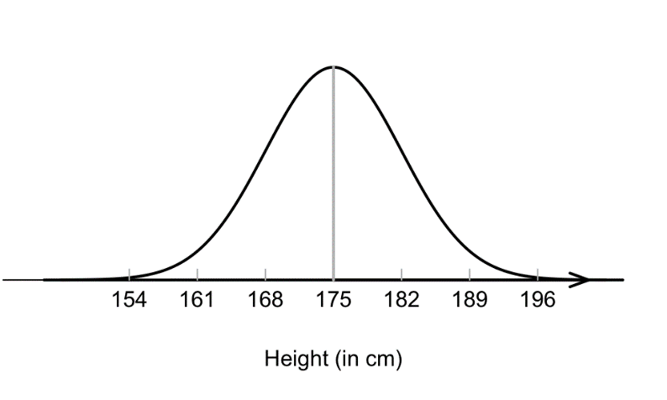
Discrete Probability Density Continuous Probability Density

Probability Density Function, f(x) for Continuous Random Variables

If $X$ is a continuous random variable, then it does not make sense to specify $P(x)$ for individual values of $X$. In fact,

$P\left(X=x\right)= ________$ for each individual value $x$

Instead, we only specify probabilities for $X$ being within a given interval of values.
e.g., $P\left(Height between 175cm and 182cm\right)= 0.34$


Definition If $X$ is a continuous random variable, then a probability density function (pdf) for $X$ is a function $f(x)$ where, for any real number $b$,
$$P\left(X≤b\right)=\int_{-∞}^{b}{f(x)}dx$$

Properties of a PDF

- Events associated with continuous random variables are always in the form of intervals; a ≤ X ≤ b, where a and b represent two distinct values.

= area under f(x) between x=a and x=b
- f (x) ≥ 0 for all x.

- Total area beneath curve is equal to 1.

We can also define a cumulative probability density function, F(x), such that

= area under f(x) up to x
The mean, μ, and the variance, σ², of a continuous random variable are given by:

Uniform Probability Distribution

The simplest kind of continuous distribution is the uniform distribution, in which every possible value of the random variable is equally likely.

Mean (Expected Value): $μ =\frac{a + b}{2}$

Variance = $σ^{2} =\frac{{\left(b - a\right)}^{2}}{12}$

Example: A random number generator produces uniformly distributed floating-point numbers between 0 and 20 milliseconds for simulating network jitter. What is the probability that a randomly generated delay will be:

- Less than 5ms?

- Between 8 and 11ms?

- More than 1.5 standard deviations away from the average?

- Exactly 4ms?

Normal Probability Distribution
The most common continuous distribution is the Normal Distribution:

Properties:
- Bell Shaped

- Symmetric about µ

- Fits the equation Shape and position depend on µ and σ.

- Areas are difficult to compute since f is not integrable.
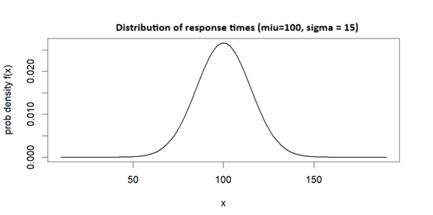
Example The response time of a web API follows a normal distribution with μ = 100ms and σ = 15ms (written as X ~ N(100, 15)). Using R, find the probability that a request takes longer than 120ms

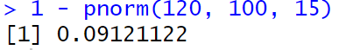

Standard Normal Distribution (z-distribution):

Normal distribution with μ = 0 and σ = 1.

Recall: mean of the z-scores is always 0 and the standard deviation is always 1.

Example: A temperature sensor in a data center has a calibration error that is normally distributed with μ = 0.00°C and σ = 1.00°C when measuring the actual temperature.
Problems:
- Probability sensor reads between 0°C and 1.35°C above actual
- Probability of reading exactly 1°C error
- P(-1.35 ≤ z ≤ 1.35)
- P(z > 1.35)
- Find the 75th percentile (i.e. what score separates the bottom 75% of the data from the top 25%)

Non-Standard Normal Distributions

We can easily convert between non-standard normal to standard normal by calculating the z-scores of a non-standard normal distribution.

Example:
The latency experienced by packets traversing a network backbone is normally distributed with μ = 4.35ms and σ = 0.500ms.
Problems:
- a) Probability of latency between 4.35ms and 5.00ms
- b) Probability of latency exceeding 5.00ms (SLA violation)
- c) 95th percentile latency (important for SLA monitoring)

Example:
In a binary system, information is represented by electrical signals - for instance, voltages. One voltage represents the bit 0 and the other the bit 1.

Due to voltage fluctuation in the circuit, the input terminal of a digital circuit does not receive the intended voltage; instead, the signal it receives is a random phenomenon, the original signal being distorted by channel noise. Very often, the noise is modelled as a normally distributed random variable and is termed Gaussian noise.

Problem:
Define bits 0 and 1 as follows: 0 (2 volts) 1 (3 volts)
Suppose noise is Gaussian (Normal) with μ = 0 v, σ = 0.22 v and the receiver interprets signals according the scheme indicated in the figure.
SENDER

0 = 2 v
1 = 3 v
NOISE
RECEIVER

0 if < 2.6 v
1 if ≥ 2.6 v

Determine the probability that the receiver will interpret a signal incorrectly, assuming that bits 0 and 1 are sent with equal frequency.

Solution:
Two possible errors can occur.

1 can be received as a 0:
The transmitted signal is 3 volts and the receiver receives a signal less than 2.6 volts. This occurs when the noise X is less than -0.4 volts.

0 can be received as a 1:
The transmitted signal is 2 volts and the receiver receives a signal greater than 2.6 volts. This occurs when the noise X is greater than or equal to 0.6 volts.

If we assume that 0’s and 1’s are equally likely, we have:

P(Error)=

Exponential Probability Distribution

It has been shown that the exponential probability distribution often provides an excellent model of service times in waiting line situations, as well as times to failure, which we will encounter in our unit on reliability.

A random variable X is said to possess an exponential distribution and to be exponentially distributed if it possesses the density function

Mean and Variance:
μ = β (mean time between events)
σ² = β ²

For instance, A production server generates error log entries at an average rate of 12 errors per hour. Assume the time between consecutive error log entries follows an exponential distribution.
Given Information:
- Average rate: 12 errors per hour
- Time between errors follows an exponential distribution
- Mean time between errors: β = 1/12 hour = 5 minutes
- Rate parameter: $\frac{1}{β}=$0.2 errors per minute

As with the normal distribution, in order to calculate probabilities, we need to find the areas beneath this curve.

Using the exponential probability density function and integration we can derive the exponential cumulative density function.$P\left(X≤t\right)=\int_{0}^{t}{\left(\frac{1}{β}e^{-\frac{x}{β} }dx\right)}$

Exponential Cumulative Density Function

$$P(X t) =$$

This formula gives the area beneath the curve between 0 and t. The area is simply the probability of randomly selecting a value between 0 and t.

Example: in the error log example:
a) What is the probability that the next error log entry occurs within 3 minutes of the previous one?

b) What is the probability that the time between two consecutive errors is between 5 and 10 minutes?

c) Find the 75th percentile of inter-error times. This threshold is useful for setting up monitoring alerts—if an error hasn't occurred within this time, it might indicate the logging system itself has failed.

Example
A web server receives an average of 30 requests per minute. Assume the time between requests follows an exponential distribution."
Problems:
- a) Probability that the next request arrives in less than 1 second
- b) Probability between 2 and 4 seconds
- c) 75th percentile of inter-arrival times (useful for capacity planning)

Example
The time until a microcontroller experiences a memory leak requiring a system restart follows an exponential distribution with μ = 50 days. Find the probability the system will need a restart in less than 20 days.

